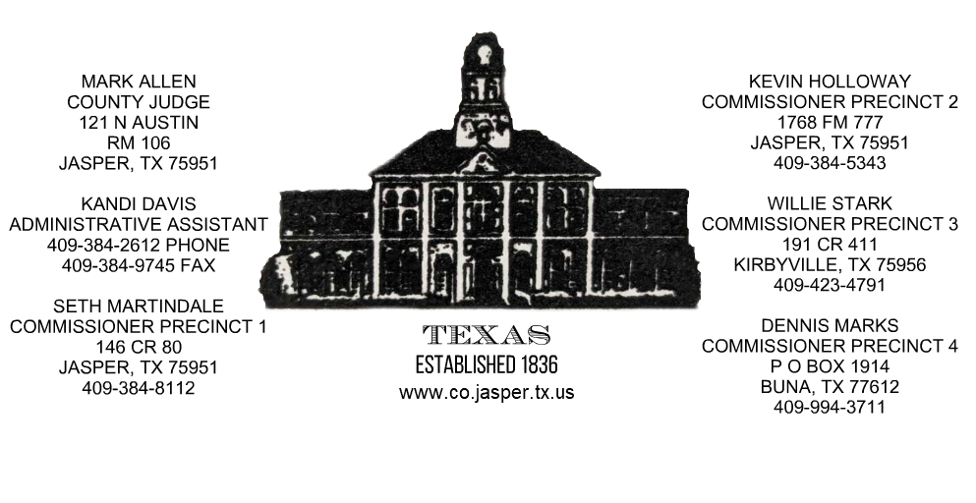

To Whom it may Concern:

This letter is to confirm that the County of Jasper does not require building permits or perform building inspections in any unincorporated areas of the county, does not require a Certificate of Occupancy, nor has the Commissioners’ Court passed any ordinances regulating zoning other than in the airport or floodplain areas.

Yours Truly,

Septic Permitting is through TCEQ: 409-898-3838

Flood Zone information, Emergency Management:
Billy Ted Smith 409-994-2543

SETRPC 911 Addressing: 409-347-1911 ext. 6102

